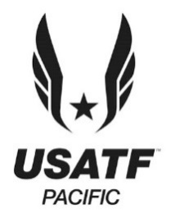
USATF Pacific Board of Athletics
7:30pm-9:05pm, May 20, 2025
Info: | Zoom meeting registration and access here. For more information email corilevans@gmail.com.

- 7:30pm-7:35pm: Roll Call – Cori Evans
- 7:36-7:40pm: Cori-Review unapproved minutes of March 18, 2025.
- 7:41-7:49pm: Treasurer’s Report-Jason or John.
- 7:50-7:55pm: Foundation Report-Stephanie Brown
- 7:56-8:05pm: Strategic Planning progress, JR. report
- 8:06pm-8:35pm: Status on committee nominations – Cori Evans
- 8:36pm-8:41pm: Report from Youth Chair-Eric Stuart on PA Top 8 & Region 14
- 8:42-8:50pm: Officials Report-Phil Leake
- 8:51pm-8:56pm: Budget for all committees are due at the end of July-Treasurer
- 8:57pm-9:05pm Championship Competition Events :1) MUT bid for the 50K 2025 Marin Headlands USATF Championships again from a successful event in 2024. 2) CIM awarded the National Marathon Championships in 2025 & 2026. 3) November 1, 2025 National Masters 5K Cross Country Championships awarded to the PA, Andrew Crawford, RD, LOC: Rick & Kathi Berman, Don Porteous, Carl Rose, XC Chairs, & Irene H.
- Nov 2025 D1 West Regional Cross Country in Sacramento
- Nov 2026 D1 & D2 Cross Country in Sacramento

Please submit your reports to Cori Evans for posting. Next meeting: Sept 2025, Have a nice summer and work on the budget!
Irene Herman

