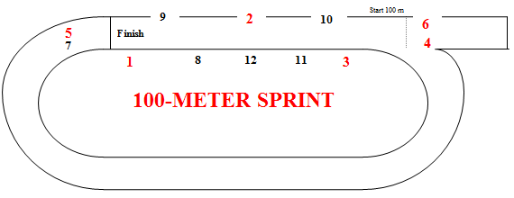

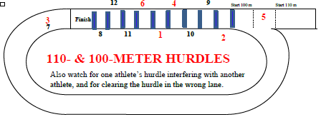

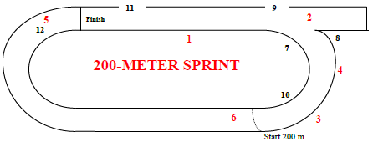

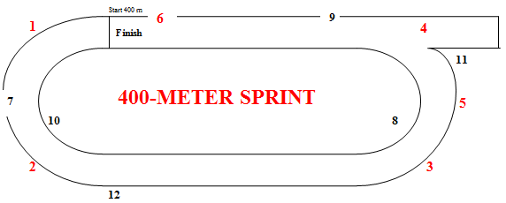

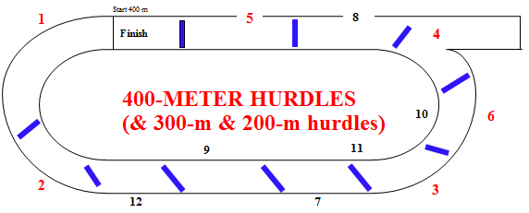

Umpires’ Positions
USATF-Pacific v.1August16

Hurdle Infractions:
Foot or leg below top of hurdle (hooks hurdle) [168.3(a)] [SC 169.4(b)]
Didn’t jump each hurdle (ran around or hand pushed over) [168.3] [SC 169.4]
Deliberately knocked down hurdle [168.3(b)]
Didn’t stay in lane (interfered {with whom?} or shortened race) [168.3]
Both feet not off ground for an instant (Masters - didn’t jump) [332.2(i)]
Stepped to one side or the other of water jump or SC hurdle [SC 169.4(a)]
Interference – who did it and who was impacted?
Jostled, ran across, or obstructed so as to impede another competitor [163.4]
Assistance – who provided it to whom? [144.2]
Pacing by persons not participating or lapped or about to be lapped [144.3(a)]
Possession or use by athlete of video, audio, or communication device [144.3(b)]
Aided by technology or appliance [144.3(c)] Personal assistance marker [163.2]
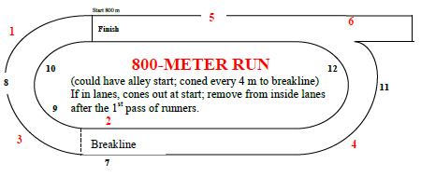

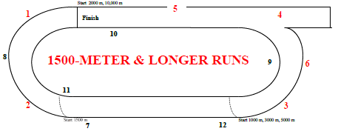

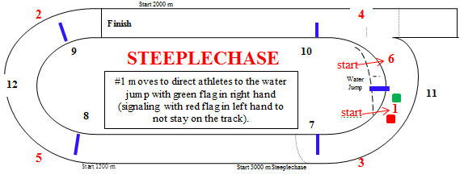

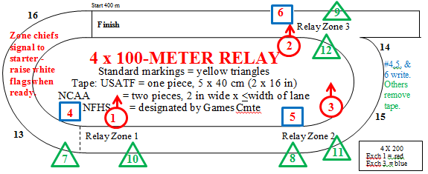
[Rule 170.5]

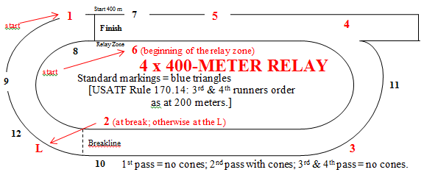
Lane Violations:
USATF: 1 step of either foot on or over inside line [163.5]
NCAA: 2 consecutive steps of any feet
NFHS: 3 consecutive steps of any feet
Cut in before breakline [163.5]
Did not finish in correct lane [163.5]
Relay Violations:
Exchanged baton before or after zone [170.17]
Accelerated before zone [4x100 run-up/170.12; 4x400/170.13]
Incorrect recovery of dropped baton [170.16]
Impeded/did not maintain lane position [170.18]
Assisted outgoing runner by pushing [170.19]
Baton not carried by hand [170.16]
Failure to participate [142.3], except youth [302.2(g)]
Left track voluntarily and returned [163.6(a)] Unsporting conduct [125.10]

Hurdle Placement and Height Comparison – Outdoor Meets

Organization/Age Group Distance Number Height To 1st Between Last to Finish
Standard color

MEN Order
Junior High 110 10 33” 13.72 m 9.14 m 14.02 m BLUE
High School 110 10 39” 13.72 m 9.14 m 14.02 m BLUE
NCAA, USATF 110 10 42” 13.72 m 9.14 m 14.02 m BLUE
Junior High 200 5 30” 50 m 35 m 10 m
High School 300 8 36” 45 m 35 m 10 m
NCAA, USATF 400 10 36” 45 m 35 m 40 m
NCAA, USATF 3000 SC 28 (7 water) 36” 5 jumps/lap after fin. line passed 1st time; water jump 4th BLACK
Boys 11-12 80 8 30” 12 m 7.5 m 15.5 m #8
Boys 13-14 100 10 33” 13 m 8.5 m 10.5 m YELLOW #5
Boys 15-16/Men 17-18 110 10 39” 13.72 m 9.14 m 14.02 m BLUE #1,2
Boys 13-14 200 5 30” 20 m 35 m 40 m
Boys 15-16/Men 17-18 400 10 36” 45 m 35 m 40 m
Boys 15-16/Men 17-18 2000 SC 18 (5 water) 36” 5 jumps/lap after fin. line passed 1st time; water jump 4th BLACK
MASTERS MEN
30-49 110 10 39” 13.72 m 9.14 m 14.02 m
50-59 100 10 36” 13 m 8.5 m 10.5 m
60-69 100 10 33” 12 m 8 m 16 m
70-79 80 8 30” 12 m 7 m 19 m
80+ 80 8 27” 12 m 7 m 19 m
30-49 400 10 36” 45 m 35 m 40 m
50-59 400 10 33” 45 m 35 m 40 m
60-79 300 7 30” 50 m 35 m 40 m (same locations as 400)
80+ 200 5 27” 20 m 35 m 40 m (same locations as 400)
30-59 3000 SC 28 (7 water) 36” 5 jumps/lap after fin. line passed 1st time; water jump 4th BLACK
60+ 2000 SC 18 (5 water) 30” 5 jumps/lap after fin. line passed 1st time; water jump 4th BLACK
__________________________________________________________________________________________________

Organization/Age Group Distance Number Height To 1st Between Last to Finish Standard Color

WOMEN Order
Junior High 100 10 30” 13 m 8.5 m 10.5 m
High School 100 10 33” 13 m 8.5 m 10.5 m
NCAA, USATF 100 10 33” 13 m 8.5 m 10.5 m
Junior High 200 5 30” 50 m 35 m 10 m
High School 300 8 30” 45 m 35 m 10 m
NCAA, USATF 400 10 30” 45 m 35 m 40 m
NCAA, USATF 3000 SC 28 (7 water) 30” 5 jumps/lap after fin. line passed 1st time; water jump 4th BLACK
Girls 11-12 80 8 30” 12 m 7.5 m 15.5 m #7
Girls 13-14 100 10 30” 13 m 8 m 15 m red tape #6
Girls 15-16/Women 17-18 100 10 33” 13 m 8.5 m 10.5 m YELLOW #3,4
Girls 13-14 200 5 30” 20 m 35 m 40 m
Girls 15-16/Women 17-18 400 10 30” 45 m 35 m 40 m
Girls 15-16/Women 17-18 2000 SC 18 (5 water) 30” 5 jumps/lap after fin. line passed 1st time; water jump 4th BLACK
MASTERS WOMEN
30-39 100 10 33” 13 m 8.5 m 10.5 m
40-49 80 8 30” 12 m 8 m 12 m
50-59 80 8 30” 12 m 7 m 19 m
60+ 80 8 27” 12 m 7 m 19 m
30-49 400 10 30” 45 m 35 m 40 m
50-59 300 7 30” 50 m 35 m 40 m (same locations as 400)
60-69 300 7 27” 50 m 35 m 40 m (same locations as 400)
70+ 200 5 27” 20 m 35 m 40 m (same locations as 400)
All ages 2000 SC 18 (5 water) 30” 5 jumps/lap after fin. line passed 1st time; water jump 4th BLACK
[from USATF Best Practices]
———————————————————————————————————————————————————————————————————————————————————————————————————————————————————————————————————————

